**EXPDP(DATAPUMP) BACKUP DOCUMENT**

* We should maintain expdp (Datapump) backup, here follow the below steps for taking logical backup.
* Connect server and export required database as show below:

ps -ef|grep pmon

export ORACLE_SID=IMBDB1

connect the database and check the status of database:

sqlplus / as sysdba

select name, open_mode, database_role from v$database;

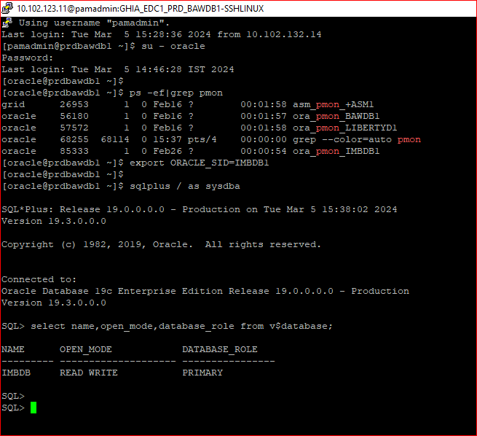

* Check the existing directory for backup, if we have existing directory path, we will use that path location otherwise create a new directory.
* set lines 200 pages 200

col directory_name for a40

col directory_path for a40

select directory_name, directory_path from dba_directories;

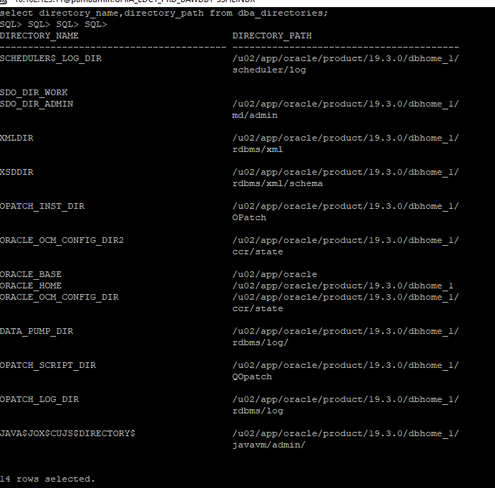

So, we don’t have existing datapump directories for backup. Now we should create new directory as per below following steps.

Note: Before creating directory check the free space of backup directory.

* df -h

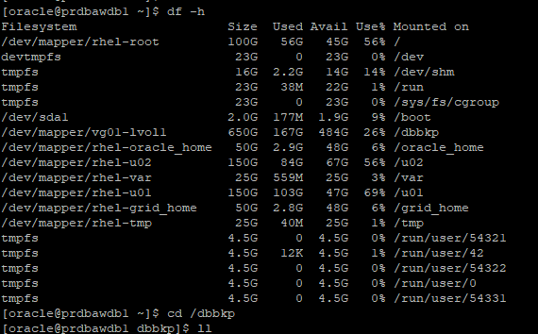

* We have enough space to take backup on “/dbbkp” directory.

Go to that location and create a new directory for store backup pieces.

* cd /dbbkp
* mkdir data_pump

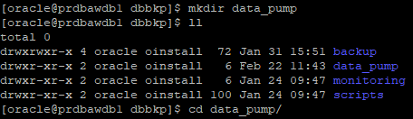

* cd data_pump
* mkdir imbdb
* cd imbdb
* pwd

we are at backup location “/dbbkp/data_pump/imbdb”

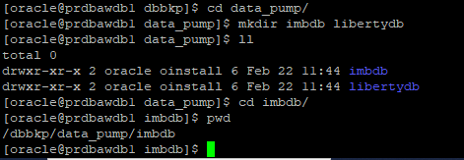

* We have created directories physically. Now, giving name to entire path location using sql prompt (logically).
* create directory datapump_imb as ‘/dbbkp/data_pump?imbdb’;

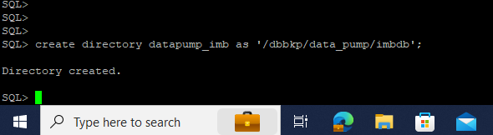

* Check whether directory created or not.
* set lines 200 pages 200

col directory_name for a40

col directory_path for a40

select directory_name, directory_path from dba_directories;

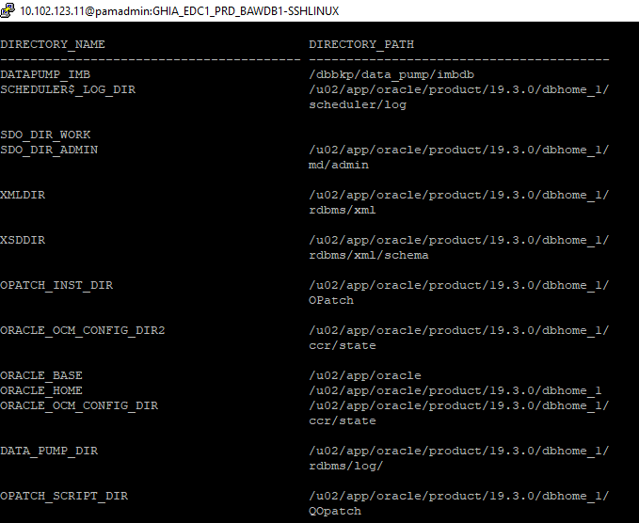

* Giving grant permission to the directory for taking backup.
* grant read, write on directory datapump_imb to sys;
* grant imp_full_database, exp_full_database to sys;

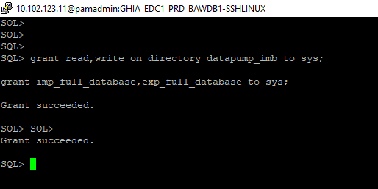

Prepare shell script for backup:

#!/bin/bash

export ORACLE_SID=IMBDB1

export ORACLE_HOME=/u02/app/oracle/product/19.3.0/dbhome_1

export LD_LIBRARY_PATH=/u02/app/oracle/product/19.3.0/dbhome_1/lib:/lib:/usr/lib

export PATH=$ORACLE_HOME/bin:$PATH:/usr/local/bin:

export TIMESTAMP=$(date +"%d-%^h-%Y");

export EXP_DIR=/dbbkp/data_pump/imbdb;

echo =======

echo Export command

echo =======

echo $ORACLE_HOME

$ORACLE_HOME/bin/expdp \'system/Oracle123 as sysdba\' full=y cluster=n PARALLEL=6 directory=datapump_imb dumpfile=expdp_full_${TIMESTAMP}_%U.dmp logfile=expdp_full_${TIMESTAMP}.log;

exit;

* Create a shell file and dump above backup script to that file. Give OS level permission to the file.
* vi expdp_full_imbdb.sh

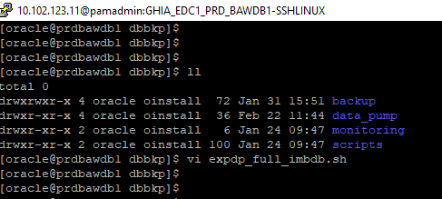

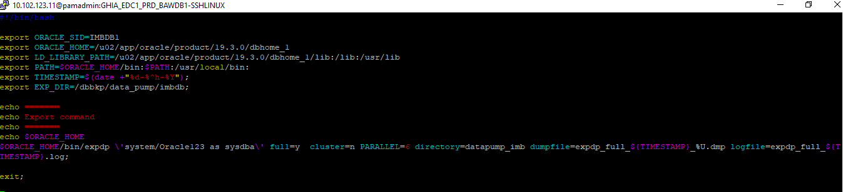

* Giving permission to the file because of to execute that file.
* chmod 755 expdp_full_imbdb.sh

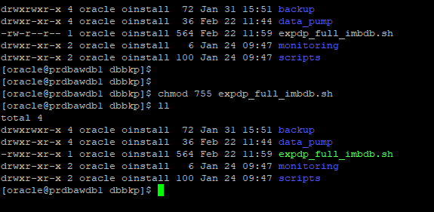

* Run the above backup file as per below command.
* ./ expdp_full_imbdb.sh

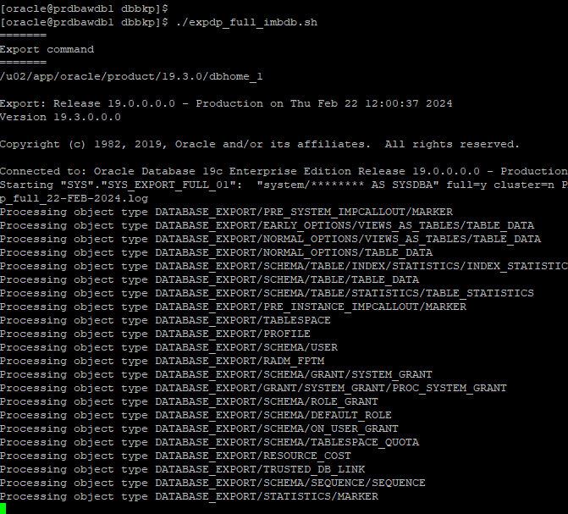

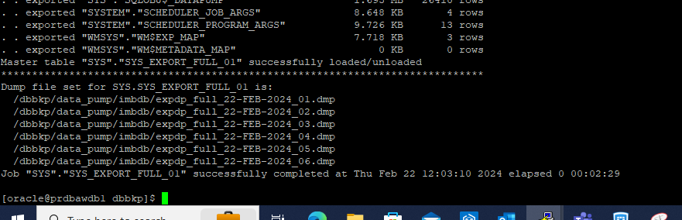

* After execution of backup file, we should have checked the status of backup at physical location.
* cd /dbbkp/data_pump/imbdb
* ll

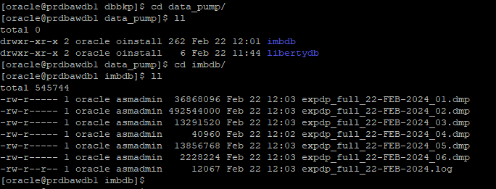

* Backup has done. Now, to be schedule this backup script at crontab for daily.
* crontab -e

* We have created directories and prepared backup shell script for the rest of databases like LIBERTYDB and BAWDB. And scheduled in Crontab on a daily backup basis.